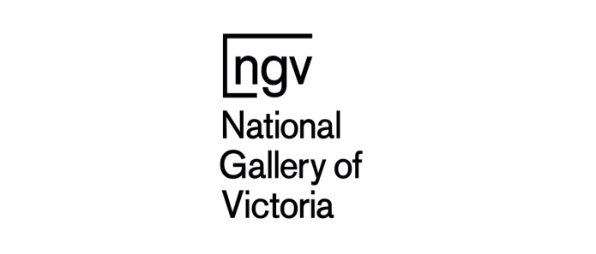

Grade 5/6 Excursion
National Gallery of Victoria

25th February, 2019

Dear Parents/Guardians
On Thursday 28th of March, the Grade 5/6 students are going on an excursion to the National Gallery of Victoria as part of the Primary Years Programme (PYP) unit ‘Who We Are’. The central idea is “Learning about cultures can help us to understand ourselves and celebrate our differences”. At the gallery, students will be exploring the Escher X Nendo Exhibition. We will be travelling to the gallery by train. The cost for this excursion inclusive of travel is $12.20.
We will leave school at 8.50am sharp and return before 3.15pm. Students must be in full school uniform.
On the day please pack your child’s snack and lunch into a clearly labelled plastic bag. There is no space available at the gallery for school bags, so the bag needs to be disposable. Drinks should also be sent in disposable containers (not glass) for the same reason.

Regards,

Pamela Streete Denise Mendham, Vicki King, Jason Hutchison
Principal Grade 5/6 Teachers

The due date for payment and permission slip is Monday 25th March, 2019

Grade 5/6 Excursion – National Gallery Permission

I consent for my child ________________________________________ in home group _________ to travel to the National Gallery of Victoria by train on Thursday 28th March.
I authorise the teacher in charge, where it is impractical to communicate with me, to the child receiving such medical and/or surgical treatment as may be necessary and acknowledge that I will be responsible for any costs arising from such treatment/s.
Please tick payment method and sign permission below:
Enclosed payment of $12.20
OR
Use CSEF credit (please tick if you have unallocated funds)
Please take note of the following medical/important information
Allergies/Asthma etc.: __________________________________________________________________
Parent/Guardian Name: _______________________________ _____ Signature: ______________________
Emergency Contact No: _______________________________________ Date: ____________________

PAYMENT AND PERMISSION MUST BE RECEIVED BY Monday 25TH MARCH, 2019

